**LIBRARY MANAGEMENT SYSTEM (CASE STUDY)**

* show databases;
* create database LibraryManagementSystem;
* use LibraryManagementSystem;

**SECTION TABLE:**

* create table section(

section_id int PRIMARY KEY AUTO_INCREMENT,

section_name varchar(50) NOT NULL,

opening_time time default '090000',

closing_time time

);

* desc section;

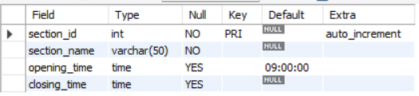

* insert into section(section_name,closing_time)

values('Department of Mathematics','150000');

* insert into section(section_name,closing_time)

values('Applied Science','140000'),

('Literature','200000'),

('Kids Section','180000'),

('Encyclopedia','190000'),

('Psychology','140000');

* select * from section;

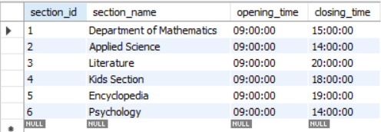

**STAFF TABLE:**

* create table staff(

staff_id int PRIMARY KEY AUTO_INCREMENT,

section_id int,

staff_firstname varchar(20) NOT NULL,

staff_lastname varchar(20),

Role varchar(20),

Age int check(age>=18),

salary float);

* desc staff;

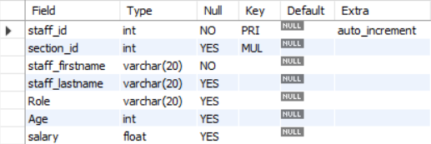

* alter table staff

add FOREIGN KEY(section_id) REFERENCES section(section_id);

* insert into staff(section_id,staff_firstname,staff_lastname,Role,Age,Salary)

values(1,'Harry','Dawson','HOD',54,60000),

(1,'Mac','Jenkins','Technical Head',46,52654),

(2,'Arun','Nandan','HOD',59,60000),

(1,'Jaideep','Singh','Librarian',42,48000),

(3,'Manish','Kumar','Technical Head',35,28000),

(2,'Kuldeep','Kale','Assistent Librarian',28,13000),

(1,'Manish','Kadam','Assistent Librarian',36,35000),

(3,'Jacob','John','HOD',58,51000),

(2,'Ravi','Subramaniam','Technical Head',24,15000),

(2,'Salim','Abbas','Librarian',47,56000),

(3,'Vishal','Dave','Assistent Librarian',28,45000),

(3,'Punit','Singh','Librarian',31,33000),

(4,'Vivek','Kubal','HOD',25,56121),

(4,'Pranit','Sonawane','Technical Head',56,75000),

(4,'Pranjal','Kadam','Assistent Librarian',35,65000),

(4,'Prachi','Pednekar','Librarian',28,37000),

(5,'Mukta','Birari','HOD',44,35000),

(5,'Sai','Kumar','Technical Head',24,65000),

(5,'Raj','Rajput','Assistent Librarian',35,72000),

(5,'Harmeet','Sharma','Librarian',55,64000),

(6,'Kavita','Pote','HOD',44,35000),

(6,'Parth','Kumar','Technical Head',25,65000),

(6,'Twisha','Rajput','Assistent Librarian',35,72000),

(6,'Yuvansh','Sharma','Librarian',54,64000);

* select * from staff;

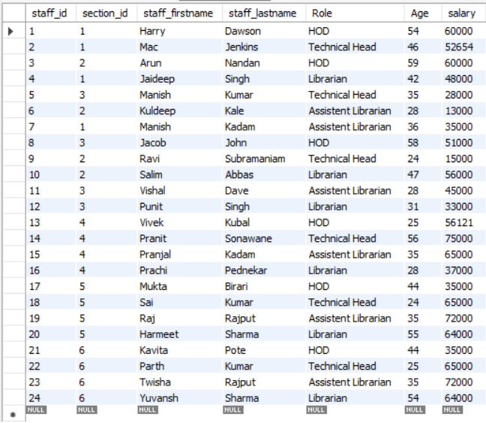

**STAFF MOBILE:**

* create table staff_mobile(

mob_id int PRIMARY KEY AUTO_INCREMENT,

staff_id int,

mobile_no varchar(20),

FOREIGN KEY(staff_id) REFERENCES staff(staff_id)

);

* desc staff_mobile;

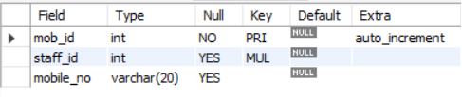

* insert into staff_mobile(staff_id,mobile_no)

values(1,"9875469315"),

(2,"9878525846"),

(3,"9535658547"),

(1,"9535251545"),

(4,"9575963215"),

(3,"9346858525"),

(3,"2457183649"),

(5,"3657495214"),

(6,"9123568452"),

(7,"9878785462"),

(8,"9999358427"),

(9,"9137842658"),

(9,"9632587412"),

(10,"9512357486"),

(10,"9874123652"),

(11,"9632147852"),

(12,"2315478954"),

(13,"3594585554"),

(14,"4218754585"),

(15,"9668686868"),

(16,"9775849545"),

(17,"9331212545"),

(18,"9935699352"),

(19,"9354218754"),

(20,"9765428431"),

(21,"3365224155"),

(22,"3468751248"),

(23,"3654851265"),

(24,"5684972131"),

(23,"1212121221");

* select * from staff_mobile;

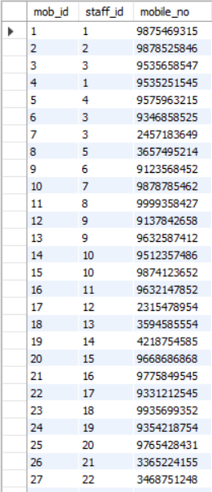

**BOOKS TABLE:**

* create table books(

book_id int PRIMARY KEY AUTO_INCREMENT,

section_id int,

book_name varchar(100) NOT NULL,

author varchar(30),

Publisher varchar(50),

copies int,

FOREIGN KEY (section_id) REFERENCES section(section_id)

);

* desc books;

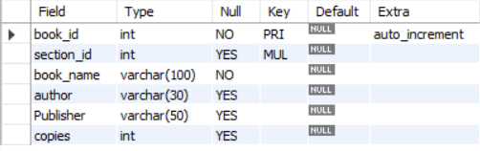

* insert into books(section_id,book_name,author,Publisher,copies)

values(1,'Mathematics for Game Programming and Computer Graphics','Penny De Byl','Packt Publishing',50),

(1,'Metamathematics: Foundations & Physicalization','Stephen Wolfram','Wolfram Media, Inc.',28),

(1,'Foundations of Applied Mathematics Illustrated Edition','Michael D. Greenburg','Dover Publications',120),

(1,'Principles and Techniques of Applied Mathematics','Bernard Friedman','Dover Publications',12),

(1,'Machine Learning: An Applied Mathematics Introduction','Paul Wilmott','Packt Publishing',42),

(2,'Everything You Need to Ace Science in One Big Fat Notebook','Michael Geisen','Workman Publishing',56),

(2,'Concepts of Physics (Part 1)','H.C. Verma','S. Chand & Company Ltd.',192),

(2,'Concepts of Physics (Part 2)','H.C. Verma','Bharti Bhavan',232),

(2,'Super Simple Biology: The Ultimate Bitesize Study Guide (DK Super Simple)','DK','DK Children',51),

(2,'The Biology Book: From the Origin of Life to Epigenetics, 250 Milestones in the History of Biology','Michael C. Gerald','Union Square & Co',19),

(3,'The Iliad & the Odyssey (Deluxe Hardbound Edition)','Homer','Fingerprint! Publishing',75),

(3,'To Kill a Mockingbird','Harper Lee','Harper Perennial',28),

(3,'The Greatest Short Stories of Leo Tolstoy','Leo Tolstoy','Fingerprint! Publishing',74),

(3,'A Death in East Berlin: A Cold War crime thriller ','Richard Wake','Kindle',99),

(3,'A Death in East Berlin: A Cold War crime thriller ','Anthony Doerr','Scribner',55),

(3,'Then She Was Gone','Lisa Jewell','Dreamscape Media LLC',134),

(3,'The Accidental President: Harry S. Truman and the Four Months That Changed the World','A. J. Baime','Mariner Books',232),

(3,'The Happiest Man on Earth: The Beautiful Life of an Auschwitz Survivor','Eddie Jaku','HarperAudio',174),

(4,'Would You Rather Book For Kids - 300+ Hilarious, Silly, and Challenging Questions','Stephen J. Ellis','HarperAudio',450),

(4,'The Spooky Wheels on the Bus: (A Holiday Wheels on the Bus Book)','J. Elizabeth Mills','Cartwheel Books',324),

(4,'Pete the Cat: Trick or Pete','James Dean','HarperFestival',250),

(4,'Teach Your Dragon Gratitude: A Story About Being Grateful (My Dragon Books)','Steve Herman','Scribner',124),

(4,'Teach Your Dragon To Follow Instructions: Help Your Dragon Follow Directions.','Steve Herman','Scribner',124),

(4,'What Should Danny Do? School Day','Adir Levy','Elon Books',74),

(5,'Knowledge Encyclopedia Human Body!','DK','DK Children',500),

(5,"Britannica's Encyclopedia Infographica: 1000 Facts & Figures",'Penny De Byl','Britannica Books',200),

(5,'Ciencia!','DK','DK Children',200),

(6,"The Body Keeps the Score: Brain","Bessel van der Kolk M.D. ","Scribner",170),

(6,"Read People Like a Book: How to Analyze, Understand","Penny De Byl","Packt Publishing",444),

(6,"Psychology: A Complete Introduction","Sandy Mann","Teach Yourself",6);

* select * from books;

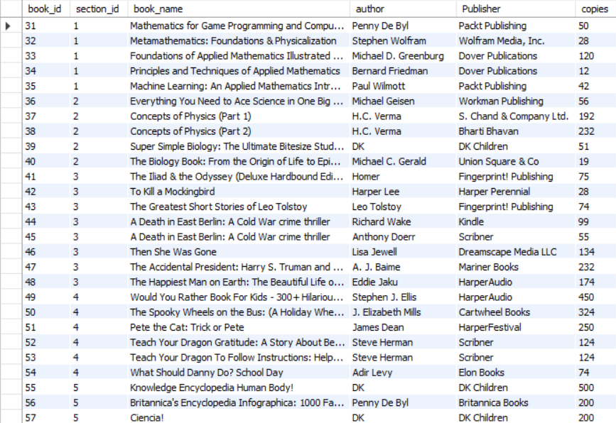



**CUSTOMER TABLE:**

* create table customer(

cust_id int PRIMARY KEY AUTO_INCREMENT,

staff_id int,

cust_name varchar(30),

book_id int check(book_id>30 and book_id<=60),

date_of_issue date,

address varchar(20),

FOREIGN KEY(staff_id) REFERENCES staff(staff_id),

FOREIGN KEY(book_id) REFERENCES books(book_id)

);

* desc customer;

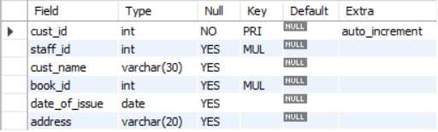

* insert into customer(staff_id,cust_name,book_id,date_of_issue,address)

values(4,"Anshul Kumbhare",31,20231001,"Belapur"),

(7,"Kunal Pradhan",33,20231004,"Panvel"),

(5,"Manish Gupta",47,20231007,"Vashi"),

(6,"Dipanshu Verma",39,20230925,"Kurla"),

(10,"Christina Pareira",40,20231014,"Panvel"),

(5,"Satish Dhavan",47,20231007,"Vashi"),

(5,"Satish Dhavan",46,20230805,"Vashi"),

(7,"Karim Bhatt",33,20231004,"Andheri"),

(19,"Kunal Gaur",57,20231012,"Panvel"),

(22,"Punit Kale",60,20231006,"Kharghar"),

(7,"Abbas Shaikh",34,20230429,"Kharghar");

* select * from customer;

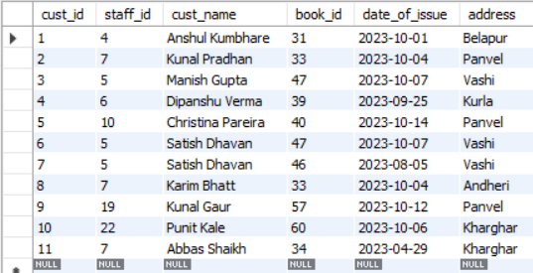

**Library Management System Question (Case Study)**

1. **Write a query to show all the databases available?**

Show databases;

1. **Create a new database LibraryManagementSystem.**

Create database LibraryManagementSystem;

Use LibraryManagementSystem;

1. **Create table staff with staff id, section id, firstname, lastname, Role, Age, salary**

create table staff(

staff_id int PRIMARY KEY AUTO_INCREMENT,

section_id int,

staff_firstname varchar(20) NOT NULL,

staff_lastname varchar(20),

Role varchar(20),

Age int check(age>=18),

salary float);

1. **Write a query to add PRIMARY KEY to the table.**

Alter table staff add PRIMARY KEY(staff_id);

1. **Write a SQL query to change the name of the column lastname to staff_lastname.**

Alter table staff rename column lastname to staff_lastname;

1. **Write a query to drop FOREIGN KEY and add again.**

Show create table staff;

alter table staff drop constraint staff_ibfk_1;

alter table staff

add FOREIGN KEY(section_id) REFERENCES section(section_id);

1. **Write a query to add and delete default constraint to section table.**

* Alter table section

Modify column opening_time time default ‘090000’;

* Alter table section

Modify column opening_time time NULL;

1. **Write a query to insert multiple values into staff table.**

insert into staff(section_id,staff_firstname,staff_lastname,Role,Age,Salary)

values(1,'Harry','Dawson','HOD',54,60000),

(1,'Mac','Jenkins','Technical Head',46,52654),

(2,'Arun','Nandan','HOD',59,60000),

(1,'Jaideep','Singh','Librarian',42,48000),

(3,'Manish','Kumar','Technical Head',35,28000),

(2,'Kuldeep','Kale','Assistent Librarian',28,13000),

(1,'Manish','Kadam','Assistent Librarian',36,35000),

(3,'Jacob','John','HOD',58,51000),

(2,'Ravi','Subramaniam','Technical Head',24,15000),

(2,'Salim','Abbas','Librarian',47,56000);

1. **Write a query to change the salary of staff whose firstname is Manish.**

Update staff set salary = 30000 where staff_firstname = ‘Manish’;

1. **Display all records of customer table.**

Select * from customer;

1. **Display staff_firstname as first name and staff_lastname as surname from staff table.**

Select staff_firstname “First name”, staff_lastname as surname from staff;

1. **Write a query to display firstname, staff_id and increment salary by 10000 of assistant librarian from staff table.**

Select staff_firstname, staff_id, salary+10000 from staff where Role = “Assistant Librarian”;

1. **Write a query to display records of staff having salary greater than 20000.**

select * from staff where salary >20000;

1. **Write a query to show records of customer with date of issue between 2023-09-25 and 2023-10-04.**

select * from customer

where date_of_issue between 20230925 and 20231004;

1. **Write a query to show records of staff having salary 48000,28000,75000,35000.**

select * from staff

where salary in(48000,28000,75000,35000);

1. **Write a query to show first name of staff having ‘a’ as its second character.**

Select * from staff where staff_firstname like ‘_a%’;

1. **Write a query to show only 5 distinct salaries in descending order of salary.**

select distinct salary from staff order by salary desc limit 5;

1. **Write a SQL query to show firstname and lastname together as name in upper case and its total length.**

Select upper(concat(staff_firstname,” ”,staff_lastname)), length(concat(staff_firstname,” ”,staff_lastname)) as name from staff.

1. **Write a query to round off the salary of staff.**

Select round(salary) from staff;

1. **Find the day on which the books were issued.**

select date_format(date_of_issue,"%W") from customer;

1. **Calculate the date difference of all records in customer table.**

select datediff(curdate(),date_of_issue) from customer;

1. **Write a query to count total number of staff in each Role.**

select distinct Role, count(Role) as total from staff group by Role having total>=4;

1. **Cross join two tables: section table and staff table.**

select * from section cross join staff;

1. **Show book_id, book_name, author, customer_id,customer name, date_of_issue, staff id, staff name and role by left joining books and customer table and right joining customer and staff table.**

select b.book_id, b.book_name,b.author,c.cust_id,c.cust_name,c.date_of_issue,s.staff_id, concat(s.staff_firstname," ",staff_lastname) as fullname, s.Role from books b

left join customer c ON(b.book_id = c.book_id)

right join staff s ON(c.staff_id = s.staff_id);

1. **Write a subquery to find record of staff having 3rd highest salary.**

select * from staff

where salary = (select distinct salary from staff order by salary desc limit 2,1);